NDIC VISIT TO EFCC: PICTURES AND CAPTIONS
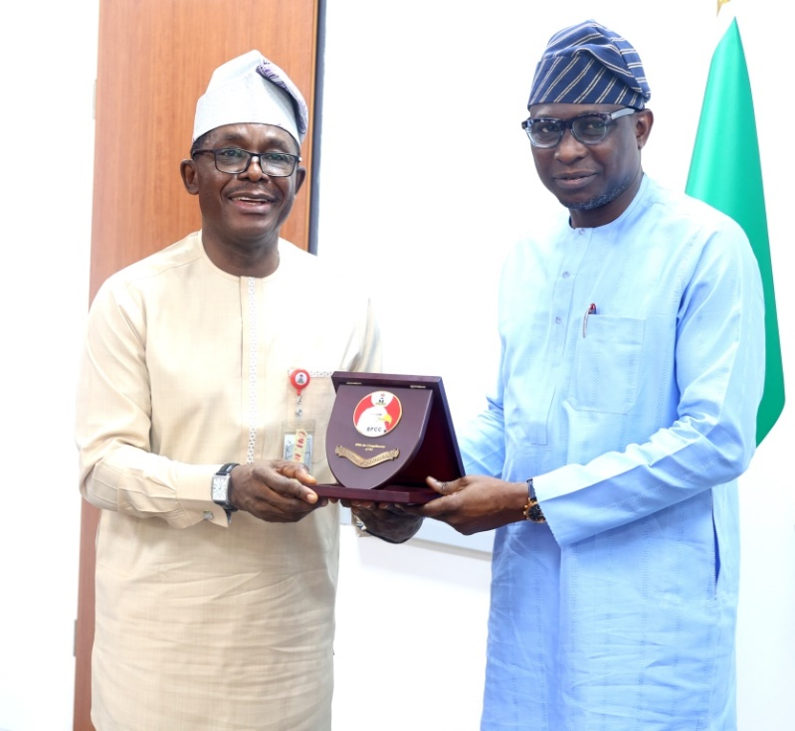
Nigeria Deposit Insurance Corporation (NDIC) Mr. Thompson Oludare Sunday receives a commemorative plaque from the Chairman of the Economic & Finance Crimes Commission (EFCC) Mr. Olanipekun Olukoyede during the NDIC Management's visit to the EFCC Headquarters in Abuja.

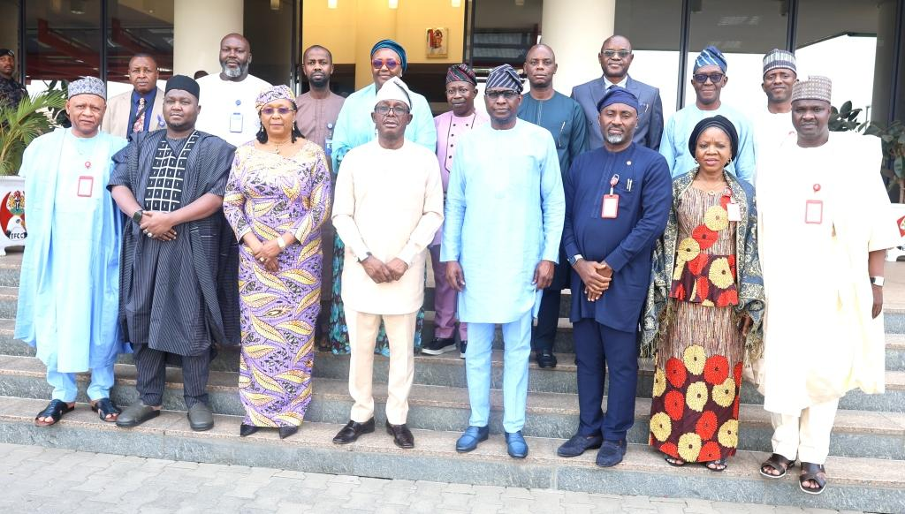
Nigeria Deposit Insurance Corporation (NDIC) delegation led by the MD/CE NDIC Mr. Thompson Oludare Sunday including ED/Corporate Services, Mrs. Emily C. Osuji, the ED/Operations Dr. Kabir S. Katata and other NDIC Heads of Departments pose for a group photograph with the Chairman, Economic & Finance Crimes Commission (EFCC) Mr. Olanipekun Olukoyede and EFCC Management staff at the EFCC Headquarters in Abuja.

