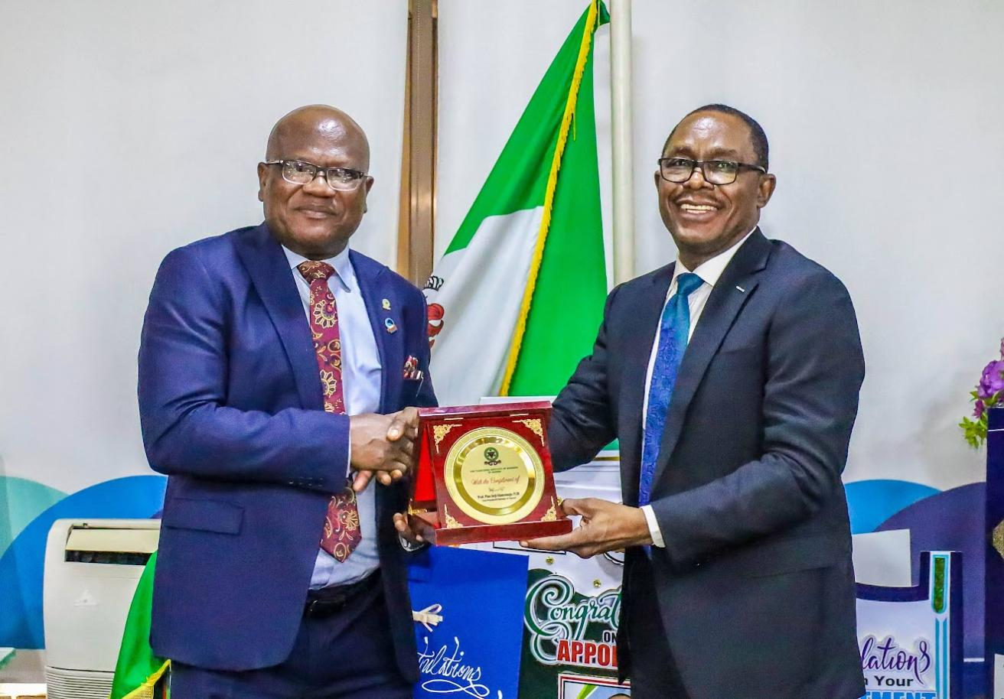

L-R: President/Chairman of Council, Chartered Institute of Bankers of Nigeria (CIBN), Prof. Deji Pius Olanrewaju presenting the Institute’s Commendation Plaque to the Managing Director/Chief Executive, Nigeria Deposit Insurance Corporation, (NDIC), Mr. Thomson Oludare Sunday during a courtesy visit at the Corporation’s Head Office in Abuja.

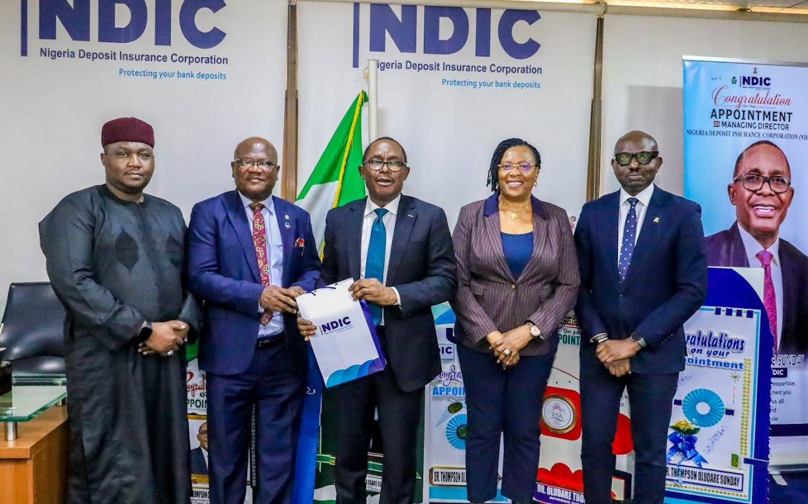

L-R: Executive Director, Operations, Nigeria Deposit Insurance Corporation, (NDIC), Dr. Kabir Sabo Katata; President/Chairman of Council, Chartered Institute of Bankers of Nigeria, (CIBN), Prof. Deji Pius Olanrewaju; Managing Director/Chief Executive, NDIC, Mr. Thomson Oludare Sunday; Executive Director, Corporate Services, Mrs Emily C. Osuji; and Registrar/ Chief Executive of CIBN, Mr. Akin Morakinyo during the CIBN’s courtesy visit at the NDIC’s Head Office in Abuja.